# How to develop WeChat application by TypeScript

## Introduction

This sample demonstrates how to develop WeChat application by TypeScript.

## Sample prerequisites

* [VS2015 with TypeScript extension](https://visualstudiogallery.msdn.microsoft.com/418d1f01-e58c-453a-a7d0-8381b562d499)
* [NodeJS](https://nodejs.org/en/)
* [NPM](https://www.npmjs.com/)
* [TypeScript toolset](http://www.typescriptlang.org/#download-links)
* [WeChat application dev tool](https://mp.weixin.qq.com/debug/wxadoc/dev/devtools/download.html?t=20161102)

## Building the sample

Each time after editing typescript code file, please run “tsc” command under the root folder which containing the file “tsconfig.json”.

## Running the sample

* Open your WeChat client on your phone and the WeChat application dev tool
* Scan the QR code in WeChat mobile client

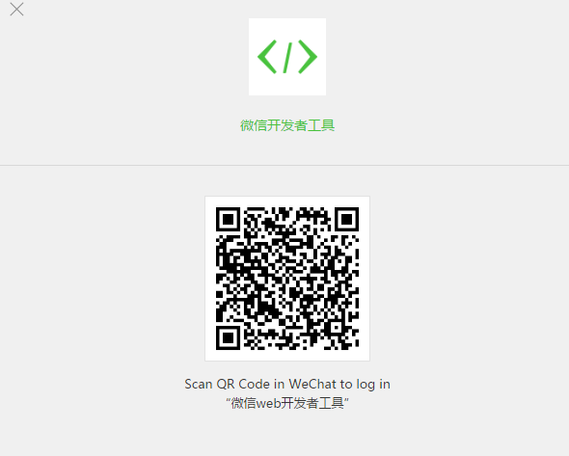

* Select the local application project

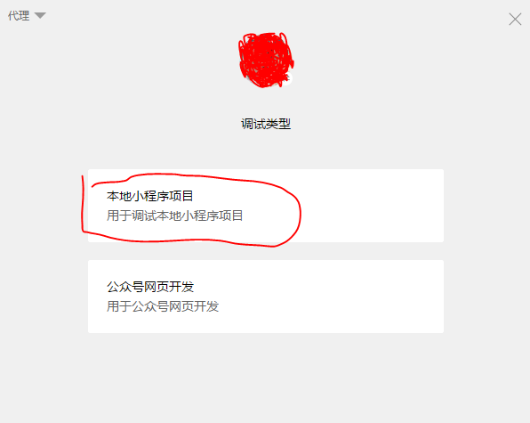

* Add new project and fill necessary information about project
* If you have no AppID, please click “No AppID”

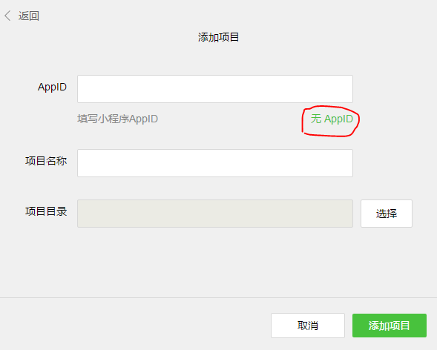

* Then you will see the application demo content in the dev tool

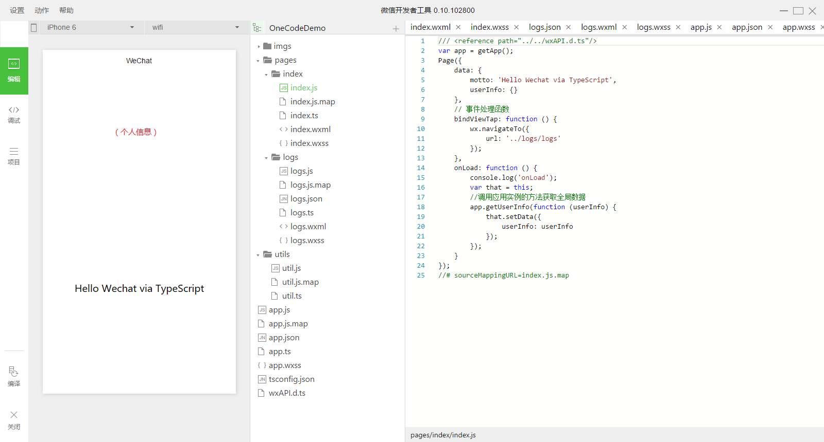

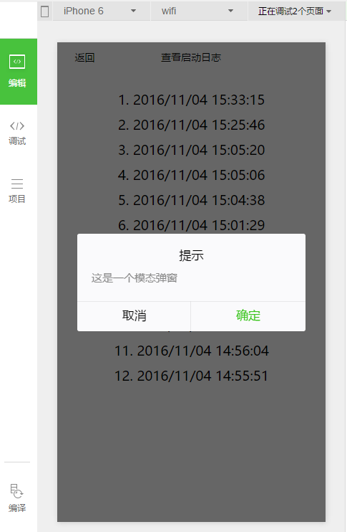

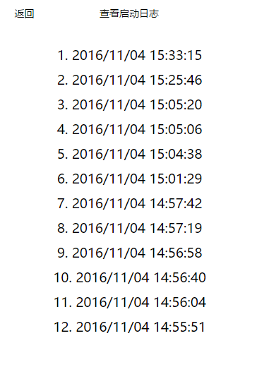

## Using the code

The WeChat application consists of two major parts:

* Application
* Page

The app is the entrance of the application. Page contains page view and page logic. For more information, please refer to <https://mp.weixin.qq.com/debug/wxadoc/dev/?t=20161102>.

**wxAPI.d.ts**

This file is WeChat js api typescript definition. You can reference it to all your typescript code and then you can get intelligence tip in visual studio because of this file.

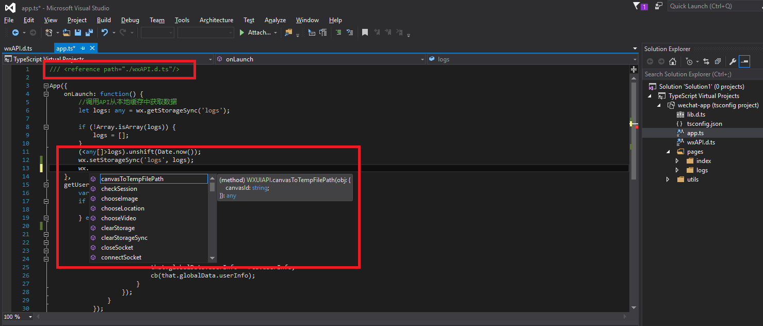

## More information

* **WeChat official dev document:** <https://mp.weixin.qq.com/debug/wxadoc/dev/?t=20161102>